**Collaboration using Laserfiche Discussions**

Do you ever wonder if other people within the organization ask the same questions as you regarding documents, folders, project, programs or processes? Laserfiche Discussions is a web resource that allows users to communicate with other colleagues or customers on topics that are important. The Discussions website available with Laserfiche solution will enable PASA employees to streamline collaboration efforts and create access to content within the organization.

**What is Laserfiche Discussions?**

Laserfiche Discussions is a website where users propose ideas, collaborate and learn. Users can begin discussions or inquire about topics for an entire community or create content within public or private groups. The Laserfiche Discussions website allows for all centralized communications in a secure discussion thread.

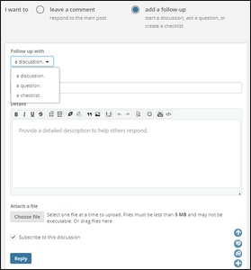

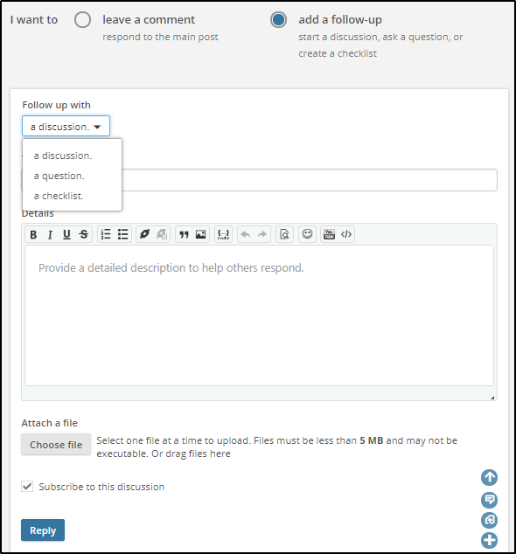

**What benefits will users of Laserfiche Discussions see?**

Laserfiche Discussions website allows users to perform several functions on the Website, including:

* **Create** - Creating content by starting discussions, posting announcements, asking questions, proposing ideas, and replying to other posts.
* **Collaborate** – Working together as a group with the correct audience regarding a specific document, folder, or more. Users can share their content with the right group. Whether they are public, private or hidden groups, there are options.
* **Subscribe** – Choose which topics and posts are of interest and subscribe. The subscription feature allows users to easily keep up with the latest conversations and subjects that are relevant to them. If a user subscribes to content, they will receive an email when new content is available.
* **Participate** – Users can reply to posts by answering questions, ask questions, or vote on answers, from within Web Access, Forms or on the Discussions page directly.
* **Upload** – The Discussions database can store uploaded files in its database, allowing users to upload documents and images to posts easily.
* **Add Websites to posts** – Users can embed external websites with an iframe when creating posts.
* **Display Ads** – Site settings allow admins to set and configure ads to display on the bottom of the sign-in page or in the sidebar of the group page. These images can even link to an external URL.
* **Earn Points** – Users can collect points when they perform specific actions like answering a question or posting a comment. Points are valued, than obtained when responses are up-voted or if the response was the approved answer. The points can then be used to earn badges or gain new titles for their user profile. The point system can all be customized to fit the organization.

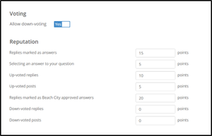

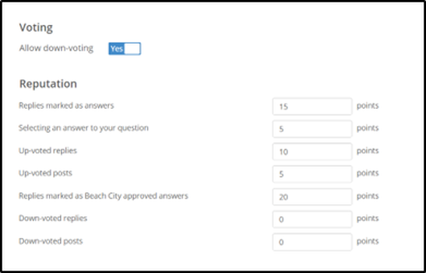

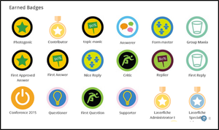

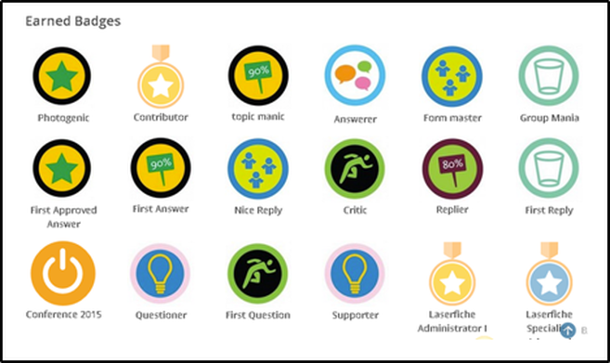

**How does Laserfiche Discussions interact with other Laserfiche Products?**

Laserfiche Discussions will interact with other products in the Laserfiche Suite, in these ways:

* **Stores Posts** – It stores posts in the Laserfiche repository, allowing secure archival.
* **Access Lists** – Discussions can gather its user lists form the Laserfiche Directory Server.
* **Laserfiche Forms** – It populates the frequently asked questions pane for starting Laserfiche Forms. This feature provides an effective way for users to seek clarification on items while filling out a form.
* **Web Access** – The Web Client 10 metadata pane includes a Discussions tab where users can start discussions and collaborate about a document or a folder. The Discussions page content is visible from either the discussions page or Web Access.

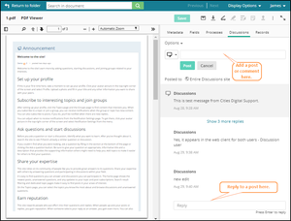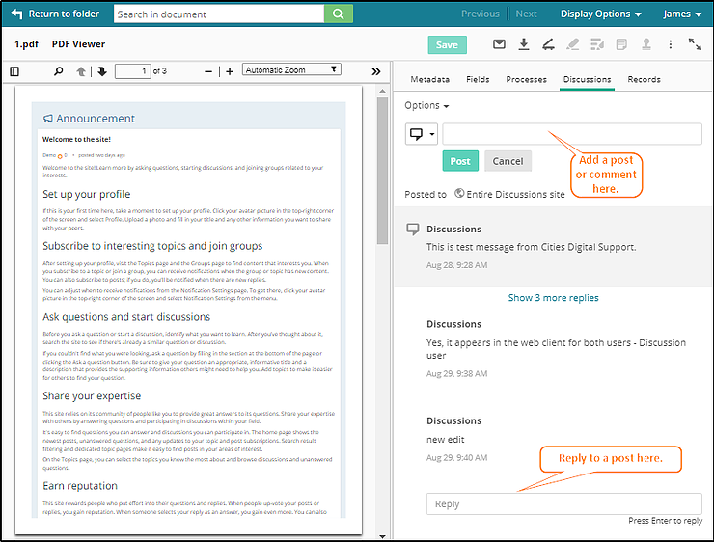

* **Mobile Friendly** – Post, request, inquire, or reply to Laserfiche Discussion’s web-page right from your mobile device, making keeping track of conversations secure and accessible.

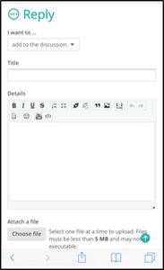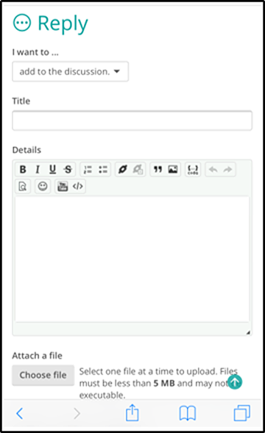

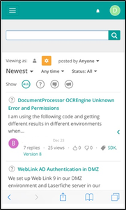 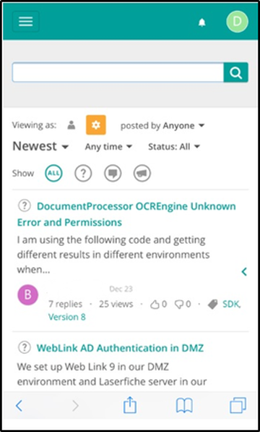

**How are organizations leveraging the Discussions Web-page?**

There are many ways that organizations are using the Laserfiche Discussions Web page, some examples include:

* **Custom Company Discussion Boards** – Organizations are creating a custom website to include company colors, logos, ads and more. These company-wide discussion boards allow users to log on, post questions, respond and more, creating a cohesive and available atmosphere.
* **Human Resources** - Human Resources Departments are using Laserfiche Discussions during the hiring process. The Discussions forum helps the department facilitate the on-boarding process for new staff, allowing multiple people to review and share comments about the candidates and evaluation.
* **IT Departments** - IT Departments are using the application internally for troubleshooting common issues or installations and allowing users to inquire about programs or processes. Sharing the information with a group help prevent the dreaded knowledge drain.
* **Review Processes** – Another typical application of the Laserfiche Discussions solution is using the discussion option within Web Access metadata to review documents or folder content within Laserfiche. This use allows for users to quickly and easily access, comment, or review a record without having to leave Laserfiche.

Helping to keep information transparent, sharing within an organization, and collaborating on tasks are all ways in which Discussions is improving workplaces. Giving users an open forum to talk about documents, processes, questions, or just brainstorming can be beneficial to the group. Laserfiche Discussions is a powerful tool for reducing redundancy in communication and making internal information more searchable, improving efficiency and saving time.